 | Number Code | picture | Dimension (mm) |  | Quantity (PCS)
1 | L 101 | 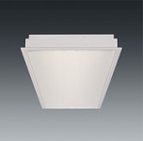 | 1548x484x90  Sheet steel, metallic grey finish  Ceiling fitter, recessed mounted | T 16 3*80w  IP 20  Class I | 14
2 | L102.1 | 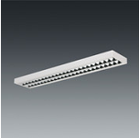 | 1488x140x63  Sheet steel housing, rectangular cross section and faces of steel  Colour: white aluminium | T16(T5)*2*49W  IP20  Class I  Flourescent tube | 8
3 | L102.2 |  | 1488x140x63  Sheet steel housing, rectangular cross section and faces of steel  Colour: white aluminium | T16(T5)*2*80W  IP20  Class I  Flourescent tube | 89
4 | L102.3 |  | 1488x140x63  Sheet steel housing, rectangular cross section and faces of steel  Colour: white aluminium | T16(T5)*1*49W  IP20  Class I  Flourescent tube | 1
5 | L103 | 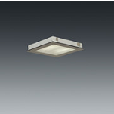 | 353x353x58mm  Sheet steel, white finish | TC-L 2x26W  EIB 1...10V  IP 20, class I | 251
6 | L104 | 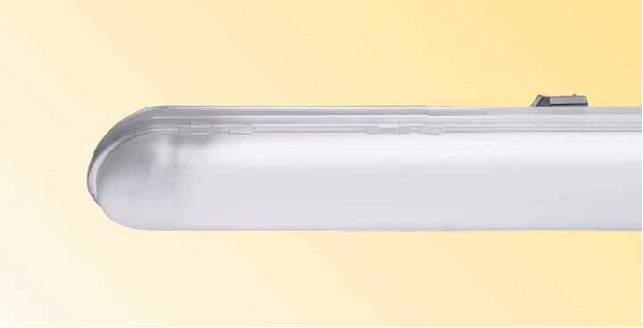 | 1550x156x70  Polycarbonate housing, injection-molded, translucent with patented labyrinth profile, without additional sealing( aging-resistant), two external fastening clips of V2A displaced to adjust to drill hole, fastening of diffuser without clips, shock-resistance | T16(T5)*2*49W  IP 65  Class I | 186
7 | L 105 |  |  |  | 6
8 | L106 | 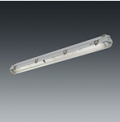 | 1550x156x70  Polycarbonate housing, injection-molded, translucent with patented labyrinth profile, without additional sealing ( aging-resistant), two external fastenning clips of V2A displaceble to adjust to drill hole, fastening of diffuser without clips, shock –resistance > 6Nm | T16(T5)*1*80W  Glasfibre reinforced polyester  Grey finish  IP65  Class I | 24
9 | L107 | 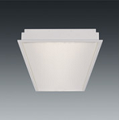 | 1548x309x48+5  Polymer, white, twin almp, corrosion resistant, acid and alkali resistant  Shallow shape with suspended lamp diffuser, PMMA clear, inside ribbed, all- round sealed, with internal reflector mirror finish, wide beam  Stainless steel | T16*2*80W  Sheet steel  Metallic grey finish  IP 20  Class I | 160
10 | L 109 | 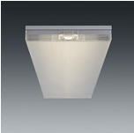 | 1570x106x88  Light control for luminaire control and other stations according to customer request. Control panel pre- programmed, for complex systems, can be extended any time | T16(T5)*1*80W  Sheet steel  Metallic grey finish  IP50  Class I | 1615
11 | L 109.1
8 | L 110 | 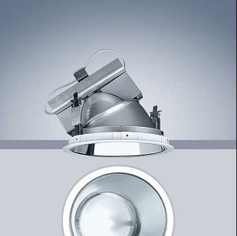 | D: 236,H: 220  High specular facetted wall washing reflector made from anodised aluminium and metallised polycarbonate- matt safety glass  Die cast aluminium body | 1 HIT-DE-CE/150W  Ip 20  Class I | 12
9 | L 111 | 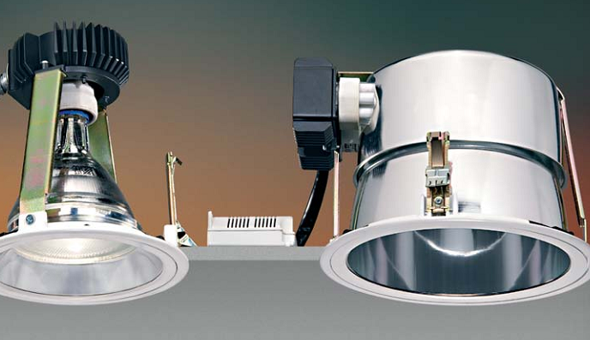 | D: 254,H: 110  Aluminium reflector, bottom optics with quick coupling via anticlockwise turn and antivibration clip to prevent accidental uncoupling, diecast aluminium body | TC-TE 2*32W  Compact fluorescent lamps  IP 20, class II
10 | L 112 | 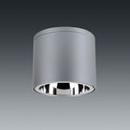 | D: 244,H: 202  Metallised polycarbonate reflector  F marking- aluminium | TC-TEL 2x26/32W  Compact flourescent lamps  IP 23  Class I | 8
11 | L 113.1 | 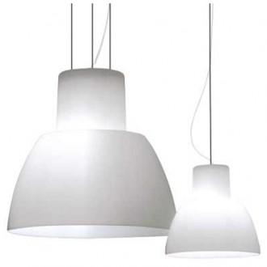 | D: 400,H: 380  Ceiling installation by means of metal module and 2m steel cable methacrylate | 1*42W  Compact flourescent lamp  IP 20  Class I | 24
12 | L 113.2 |  | D: 400  H: 380  Ceiling installation by means of metal module and 2m steel cable methacrylate | Compac 1*26W  IP 20  Class I | 8
13 | L 114 | 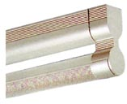 | 636x43x108 | Compac 30W  IP40,Class I  Aluminium extrusion, with die-cast aluminium end pieces and anti-glare, adjustable, perforated steel sheet hood.  White or silver metallic | 214
14 | L 115.0  L 115.1  L115.2 | 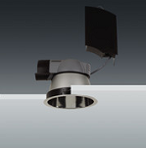 | diameter=230,  ceiling cut out=212,  recessed deth=190 | 2x TC TEL 26W  2xTC TEL 42W  1x TC TEL 26W  IP 23 | 49,43,48
15 | L 116 | 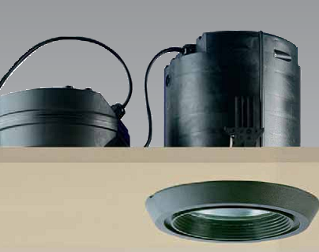 | Size 3 | 2x TC-D 18W | 28
 | L 117 | 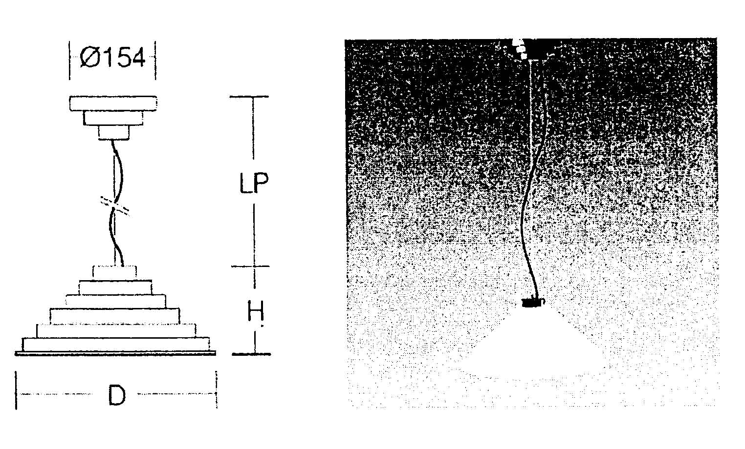 | Diameter 400mm, height: 170mm  Steel, glass tranparency  1340 lm | Ip 20, class I | 8
16 | L 118 | 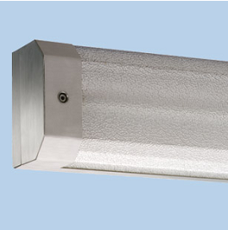 | 740x200x130 | Flourescent T8*2*18W | 509

