 | Picture | Material & Characteristic
XHLD 10 | 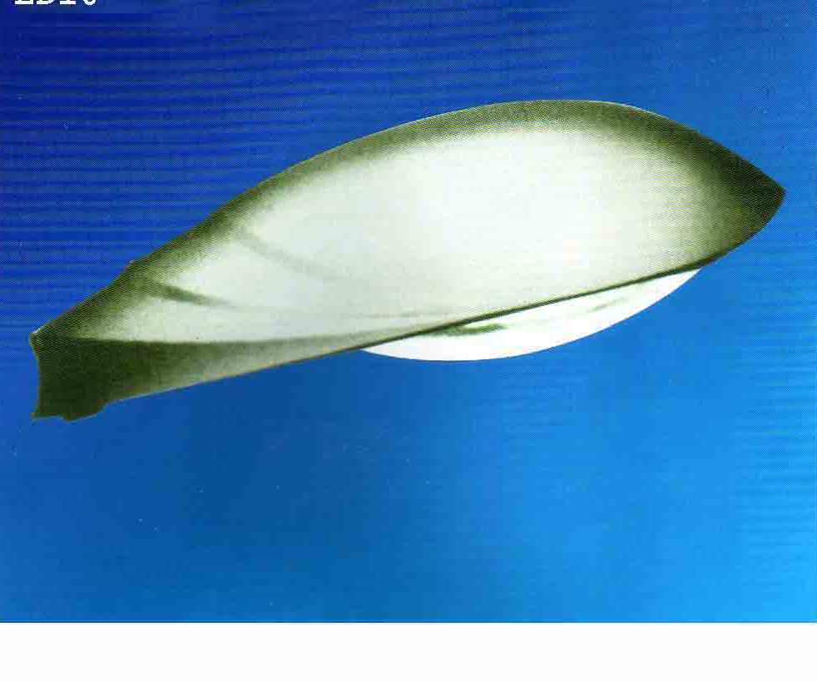 | * Innovative modern design, 2 device of body made by high stock esistar and high pressure cast aluminium .  * High pure aluminium posistive pole reflection, high afficient reflection.  * Hear recessing, materials of high transparent toughened glass good transparency, high intensity.  * inside sillicon robber alright ring, perfect ant- dust and anti- water performance IP 65  * 14 kinds of fixing ways, meet different light distribution demandsin ciffirenent aroas.  * fixing caliber D60-70mm, fixing height 8-12m | Bulb: HPS 150W- 250W- 400W  E 40  220-230V/50Hz  Poer factor: >0.85
XHTY  03 | 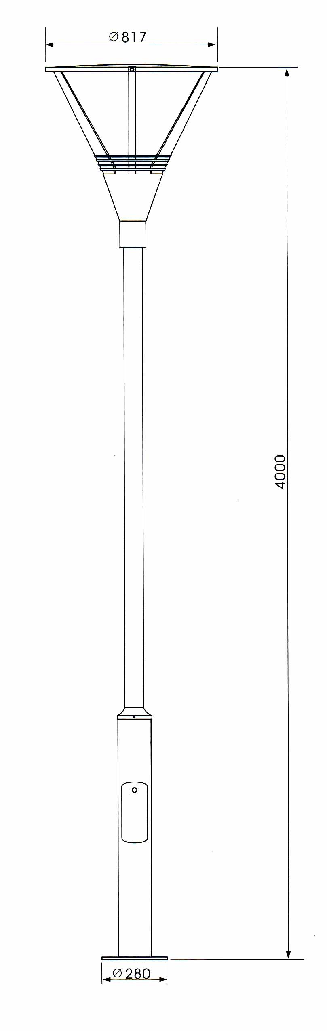  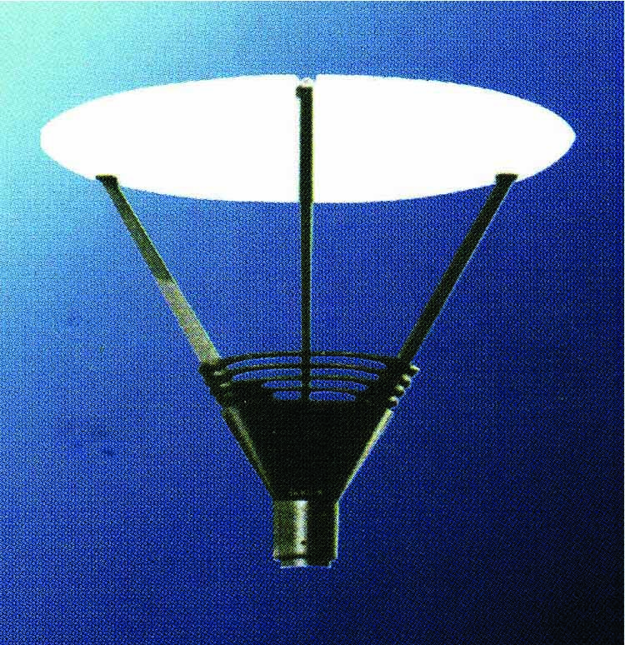 | * main body by die -cast aluminium alloy, outsie disposal with anticorrosive static electricity plastic – spur, perdurable.  * reflective board of macromolecule compound material, with good weather fastness, perfect mechanical intensity bow compass, good transparency, high intensity  * Match high quality steel fixed frame for using out of lamp – chimney  * Convenient for opening and changing of aluminant and repairing  Fix caliber: 60-90mm  Fixing height: 3-4m | Bulb: HPS 250W  Base: E40  Voltage: 220-230V/50hz  Power factor: > 0.85
XHTY 04 | 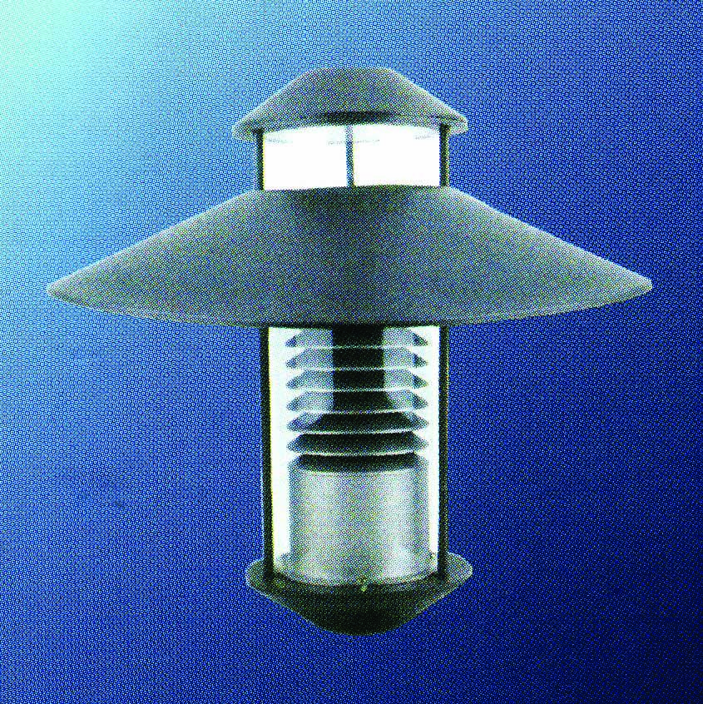 | *main body cast by aluminium alloy, outsie disposal with anticorrosive static electricity plastic – spur, perdurable  * Fence reflective mask made by high quality aluminium, butter fly shaped match light with elaborate design, lessen unnecessary lighting solution.  * adopt high intensity transparent mask, high transparency IP 55  * convenient for opening, changing of iluminant and repairing  * fixing caliber 60-100mm  * fixing height : 3-4m | Bulb: HPS 70W  E 40  220-230V/50hz  Power factor: > 0.85

Notes:
- Please quotation contains: pole and without pole

